Shawn’s Volatility Play
(work in progress ver.1.3: https://apiaryfund.com/forum/shawns-volatility-play-anything-documented#comment-[cid])

This document is an ongoing group effort to provide clues and pinpoint to exact examples of this trading methodology. As it’s combining many fundamental aspects of Price Action, years of experience and, often what seem intuitive decisions, it’s not a simple “step by step ‘strategy’, which can be “technically” described. It’s required to work yourself into this by watching and analyzing Shawn’s recorded trading videos. Look at this document as a “kick-start” that helps you to find all relevant information. If you have any suggestions, modifications, new information etc. please post this in the forum thread.

Required Market Condition:

Works only in volatile markets with powerful swings, i.e. best Euro open / US open.
Be careful when you see Wicked Markets and Outside Ranges.

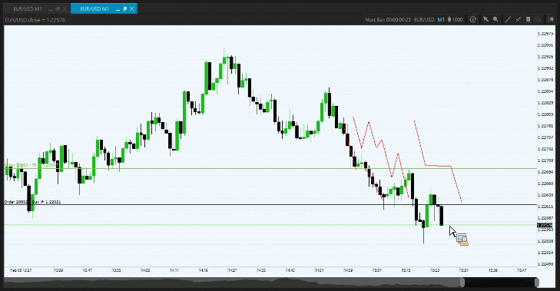

Example in Apiary “Library”, “Discussions”, Feb 8th, 2018, Trade Room, at 24.00 min

Risk/Money management:

Before going into details of this technique, it’s essential to first fully understand the correct allocation of your capital to risk.

Watch this as Shawn explains how to place trades using the Benjamin formula at the 2013 September Summit.

Setup:

- EUR/USD – M1 & M5 charts – Trades are opened on the M1 chart
- One Click Trade is configured to take 2 Pip TP and 24 Pip S/L
- 1 single trading position size is 1/5th of overall risk profile (2%)

Process:

- Analyze PA on larger TF, understand PA on 5min, open trades on 1min chart
- Define support/resistance levels, area of value
- Be aware of the price cycle and at what stage price currently is.
  - Example: Trading Room from 21st of February, Shawn predicted end of cycle based on H1 chart
- Make a plan using the 5M chart to predict direction and ‘momentum building’ which will flow down to the 1M chart
- Watch the candles tails to get insight to momentum and future direction.
- Be aware of time remaining in the 5-minute. How many 1-minutes remaining before a full paint. The pattern of each of the single 5-single candles action relative to the 5-minute.
- Wobble: “Building up a position" around defined area of value, with multiple trades, distributed in small position sizes, where each position is a small fraction of your overall risk profile, i.e. 1/5th of overall 2% risk)
- Look for consolidation areas. In setting up trades for building a position, wait for consolidation to form on both the 1M and 5M for confluence.

- The wobble can begin anytime on the play below the 5-minute directional bias midpoint, expecting price to stall and recover. Scooping up the pip

Important to understand what sides you are on … we don’t wait for patterns to complete on the M5 chart, we are part of the “creators” or “formers” of this pattern in the market. Shawn explains that at 31st minute in the first episode of Trader on the Street

Exit strategy:

- After the trade appears on the chart, re-adjust the TP / SL levels

- TP: Continuously aim to have 1 or 2 trades running for larger TP. To let these trades play out and to prevent fiddling around with them, shift your focus to wobble in multiple 2 or 3 Pip TP trades and keep sipping the little profits until you feel the price cycle has come to an end. Then close the larger TP position, which is still holding strong and made the most money.

For a look into Shawn’s mindset about this, you have to watch the 50th minute of the 2012 Fall Summit

- S/L (Hardstop), must be on the ‘RIGHT SIDE OF THE FENCE’, outside the area of value

- Keep all trades within the defined area of value, close to the price

- If trades fall out of the area of value, PEEL THEM OFF quickly <— This is one of the most important aspects of this technique.

- Close all losing trades with a Softstop! The pre-configured Hardstop is only for emergency, risk we can’t control, i.e. Internet access, platform issues etc.

Watch this video from Shawn about Stop Losses

To do: More examples ….

- When to enter long positions
- When to enter short positions
- When to move to break even
- When to increase TP - Building a runner
- When to let 2 pip TP run
- When to hedge a position

List of example Video links:

Trampoline move, Trader on the Street E02, at 23.40min

Don’t wait for signal on the 5 min, we are part of the creators of the signal on the 1min - at 31.15 min

Best market to trade this volatility based strategy

In Apiary “Library”, “Discussions”, Feb 8th, 2018, Trade Room, at 24.00 min

