Shawn’s Volatility Play
(Work in progress ver.1.7: https://apiaryfund.com/forum/shawns-volatility-play-anything-documented#comment-[cid])

This document is an ongoing group effort to provide clues and pinpoint to exact examples of this trading methodology. As it’s combining many fundamental aspects of Price Action, years of experience and, often what seem intuitive decisions, it’s not a simple “step by step ‘strategy’, which can be “technically” described. It’s required to work into this by watching and analyzing Shawn’s recorded trading videos. Look at this document as a “kick-start” that helps you to find all relevant information. If you have any suggestions, modifications, new information etc. please post this in the forum thread. https://apiaryfund.com/forum/shawns-volatility-play-anything-documented?page=0#new

Overall the following commentary can be applied to both a trending market and a consolidating market with minor differences in the manner of hedging and fading in or out of a market. However we will focus on what at Shawn Lucas’s Apiary Fund is known as “the wobbling technique” or simply wobbling.

Objectives

Scan the market for trading opportunities
Analyze current market conditions
Identify high-probability trade setups
Structure the trade before entering
Execute orders
Manage real-time trades

Required Market Condition for Consolidation Scalping:

Works only in ranging volatile markets with powerful swings of PA, i.e. best Euro open / US open.
Be careful when you see Wicked Markets and Outside Ranges of the PA.

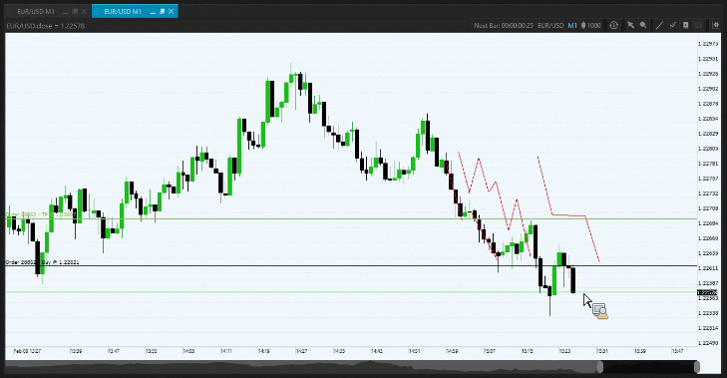

Example in Apiary “Library”, “Discussions”, Feb 8th, 2018, Trade Room, at 24.00 min

Risk/Money management:

Before going into details of this technique, it’s essential to first fully understand the correct allocation of your capital to risk.

Watch this as Shawn explains how to place trades using the Benjamin formula at the 2013 September Summit.

Platform Setup:

- EUR/USD – M1 & M5 charts – Trades are opened on the M1 chart
- One Click Trade is configured to take 2 Pip TP and 24 Pip S/L
- 1 single trading position size is 1/5th of overall risk profile (2%)

Process:

Scan the market for trading opportunities

- Analyze PA on larger TF, understand PA on 5min, open trades on 1min chart

- Define support/resistance levels, area of value

Analyze current market conditions

- Be aware of the price cycle and at what stage price currently is in.
  - Example: Trading Room from 21st of February, Shawn predicted end of cycle based on H1 chart

Identify high-probability trade setups

- Make a plan using the 5M charts to predict direction and ‘momentum building’, which will flow down to the 1M chart from the M5 chart.

- Watch the candles tails to get insight to momentum and future direction.

- Be aware of time remaining in the 5-minute. How many 1-minutes remaining before a full paint. The pattern of each of the single 5-single candles action relative to the 5-minute.

Structure the trade before entering
- Wobble: “Building up a position" around defined area of value, with multiple trades, distributed in small position sizes, where each position is a small fraction of your overall risk profile, i.e. 1/5th of overall 2% risk.

Look for consolidation areas. In setting up trades for building a position, wait for consolidation to form on both the 1M and 5M confluence.

Execute orders

- The wobble can begin anytime on the play below the 5-minute directional bias midpoint, expecting price to stall and recover. Scooping up the pip
A clear example, where Shawn demonstrates his “Wobbling Technique”, Trading Room 14/12/2018, 50th minute. Establish bias, in this case long, he starts wobbling in multiple buy positions at the lower end the consolidation phase.
A more amusing analogy and way to look at this: Shawn explains the The Drunken Stagger, Trading Room 21/12/2018, 27th minute
Important to understand what sides you are on … in Shawn’s words, ‘we don’t wait for patterns to complete on the M5 chart, we are part of the “creators” or “formers” of this pattern in the market’. Shawn explains that at 31st minute in the first episode of Trader on the Street
Manage real-time trades

- After the trade appears on the chart, manually re-adjust the TP / SL lines levels

- TP: Continuously aim to have 1 trade running for larger TP. To let this trade play out and to prevent fiddling around with it, shift your focus to wobble in multiple 2 or 3 Pip TP trades and “keep sipping” the little profits until you feel the price cycle has come to an end. Then close the larger TP position, which is still holding strong and made the most money.

For a look into Shawn’s mindset about this:

Watch the 50th minute of the 2012 Fall Summit
Watch the 55th minute of the Trading Room, 11/1/2018
Taking many small profits and give the last trade more flexibility to be a runner

- SL Hardstop, must be on the ‘RIGHT SIDE OF THE FENCE’, outside the area of value

- Keep all trades within the defined area of value, close to the price

- If trades fall out of the area of value, PEEL THEM OFF quickly <— This is one of the most important aspects of this technique.

Watch a good demonstration of this at the 50th minute of the Trading Room, 11/1/2018, How to scale out and close positions on time

Shawn doesn’t just close bad trades. You see him often PEELING off trades, or reduces risk, patiently waiting for price to return back towards order entry for a break even or small loss, but for the overall position he has build up, they are not positioned well and are a risk to keep. Trading Room 21/12/2018, 30th minute & Trading Room 14/12/2018, 26th minute

From a different perspective, Shawn also calls them “Throw away trades”, these trades are there to test the direction of price and to weed them out at earliest if this fails, with the lowest possible loss or at break even. Trading Room 14/12/2018, 56th minute

- Close all losing trades with a Softstop! The pre-configured Hardstop is only for emergency, risk we can’t control, i.e. Internet access, platform issues etc.

Shawn explains the differences of Hard Stops, Soft Stops & Apiary Stops in this video.

- Corrective Actions – Damage Control – Mitigation

Shawn explains that the most difficult part of his technique is how to manage the position when you get caught in a “Transition Phase”

40th minute of Trading Room, 14/1/18, When getting caught in a fast “transition phase”

53rd minute of Trading Room, 11/1//18 How to start mitigating, when to enter a hedged trade to offset risk/losing trades

To do: Continuously collecting more video examples & analysis

- When to enter long positions
- When to enter short positions
- When to move to break even
- When to increase TP - Building a runner
- When to hedge a position
- When to close a position
- What is a Wicked Market
- What is a Outside Range Market
- Etc.

